#### WHAT'S THE MOST IMPORTANT CRYPTO TOOL WE CAN USE TO DEFEND AGAINST EXISTENTIAL RISKS?

**-A brief case study of Russia and Ukraine invasion.**

#### -My view on the most important crypto tool we can use to defend against existential risks (cryptography).

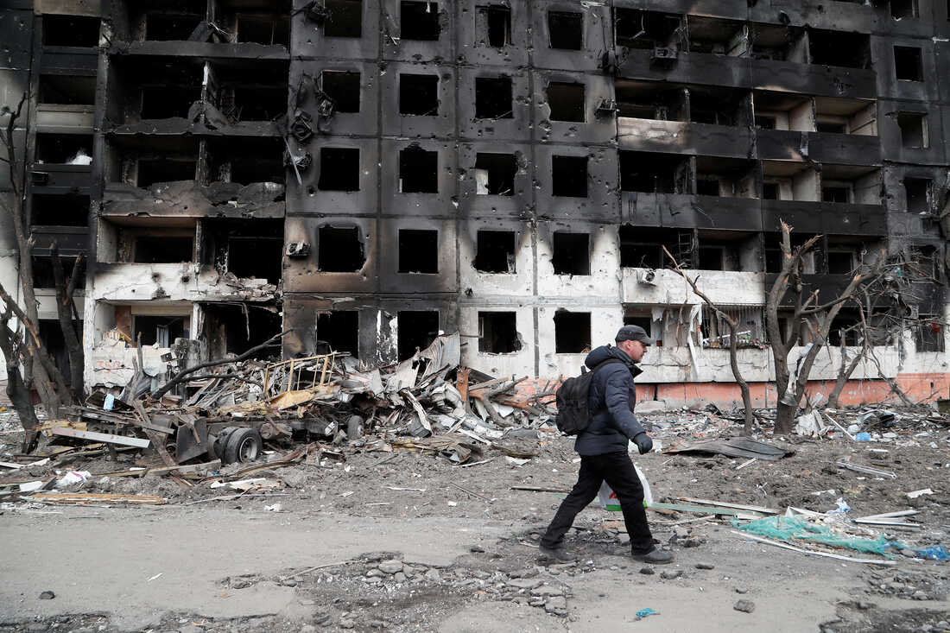

**A BRIEF CASE STUDY OF RUSSIA AND UKRAINE INVASION.**

What started as mere threats snow-balled into a full-blown war on 24 February 2022 when Russia sent its armed military to Ukraine. The invasion traces its root cause to the leaning of Ukraine towards the West - both the European Union (EU) and the North Atlantic Trade Organization (NATO)- since its independence in 1991. In addition, Russia feels threatened by Ukraine's desire to join NATO. As a result, according to the president of Russia, Vladimir Putin, the invasion was to "demilitarise and de-Nazify Ukraine.” This move was aimed at discouraging Ukraine from joining NATO. The situation is further compounded by Russia's non-recognition of the independence of Ukraine. Before the outbreak of the war, the intention was to overtake the government of Ukraine, but with Ukraine putting up a hard fight for the protection of its people and territory, Russia now seems to demand a neutral Ukraine. As a result, a full-blown war has broken out. As it spans days, weeks, and soon to months, so many atrocities have been committed by the warring parties, civilians have lost their lives, properties are destroyed, and Ukrainians have fled their homes for safety. Arguably, Russia has carried out some physical acts that could constitute crimes against Humanity. However, the mental element is lacking again. The conduct was not a 'systematic or widespread attack against the civilian population. 'The attacks were intended against Ukrainian armed forces and military objectives. Civilian casualties recorded are merely incidental or what may be referred to as collateral damages (these are injuries inflicted on persons other than the intended targets). In addition, there is evidence where Russian troops have refused to kill Ukrainian civilians despite having the chance to do so.

**MY VIEW ON THE MOST IMPORTANT CRYPTO TOOL WE CAN USE TO DEFEND AGAINST EXISTENTIAL RISKS? - WAY FORWARD**

Let take cryptography as a possible solution. The need for more advanced cryptography methods is due to the need for data to be protected more and more securely. Most of the ciphers and algorithms used in the early days of cryptography have been deciphered, making them useless for data protection. Today’s algorithms can be deciphered, but it would require years and sometimes decades deciphering the meaning of just one message. Thus, the race to create newer and more advanced cryptography techniques continues. It would only disclose its detection when pre-agreed tripwires suggesting illegal activity are triggered. That is, before a player or group of players plans to carry out a dangerous and harmful attack, the system would automatically create awareness or notify other players and possibly if the shield detects such dangerous activity, its robotic enforcement arm prevents the rogue node from engaging in hostile actions. The shield’s multipolar deployment, by which many nodes watch both relevant activity and each other, avoids allowing dangerous activity outside and within the fabric to reach a threatening level. For instance, using Public Key Cryptography, or asymmetric cryptography to secure a particular activity in the game, it uses two keys to encrypt data. One is used for encryption, while the other key can decrypts the message that is, if one key is used to encrypt, that same key cannot decrypt the message, rather the other key shall be used. Imagine a scenario whereby the case of Russia and Ukraine invasion was originally secured with a public key held by the united nation and each of the countries in question. And for any of them to carry out any harmful or dangerous attack they must get an approval by the united nation because they are holding the other key for the attack to be successfully carried out. In this sense, since the both can’t attack each other because of non approval from the UNO they would surely resolve to dialogue in finding solution on how to cooperate and coexist.

Fortunately, if this system can be executed and put in place we might be able to kill two birds with one stone, by taking the sting out of the inevitable automatic surveillance and enforcement, and use it to prevent other dangers happening in the future as we are seeing in the case of Russia and Ukraine invasion.